**How to Use Template**

**SeoFix Blogger Template**

**Contact Us :**

**Facebook : http://www.facebook.com/templatoid**

**Homepage : www.templatoid.com**

**Edit Meta Tag**

1. Go to Blogger.com log in your account blog
2. Your Blog > Template > Edit Html
3. Find (CTRL + F)

<meta content='KEYWORDS' name='keywords'/>

<meta content='DESCRIPTION' name='description'/>

* Change **Keywords** with your keywords blog

Example : fansubs, watch anime, fansubs subtitle English, etc

* Change **Description** with your description blog

Example : Fan Base Free Watch Anime Subtitle English

**Edit Meta Tag Author**

1. Go to Blogger.com log in your account blog
2. Your Blog > Template > Edit Html
3. Find (CTRL + F)

<link href='https://plus.google.com/**YOUR_ID'** rel='me'/>

<link href='https://plus.google.com/**YOUR_ID**/about' rel='author'/>

<link href='https://plus.google.com/**YOUR_ID**/posts' rel='publisher'/>

* Change **YOUR_ID** with your id google plus

Example : fansubs, watch anime, fansubs subtitle English, etc

**Valid Html5**

1. Find and Delete this below Html

<b:include name='quickedit'/>

2. add ALT and Title in your Images

<img src=’exampleurlimage’ alt=’post title’ title=’post title’ />

**Disable Custum Template for Mobile**

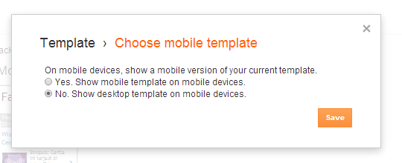

# Language and formatting

# G:\2side.PNG

# Show your profile image in index google

# G:\img.PNG

1. Open your Google Plus [[here](http://plus.google.com/me)]

2. Click **About (**[**https://plus.google.com/idgoogleplus/about**](https://plus.google.com/idgoogleplus/about)**)**

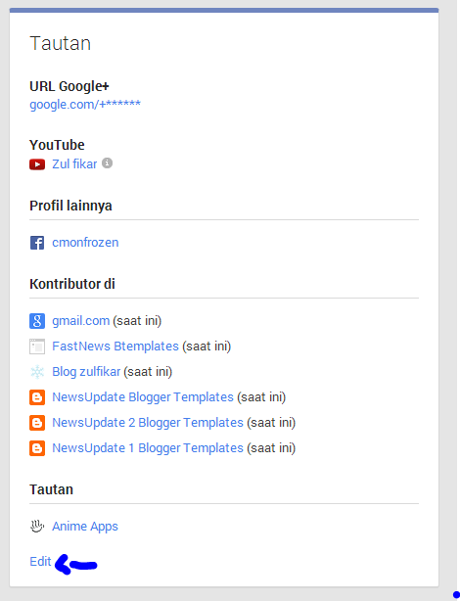

3. Click [**Edit**] then scroll.. and see like **Contributors in** or **Kontributor di**

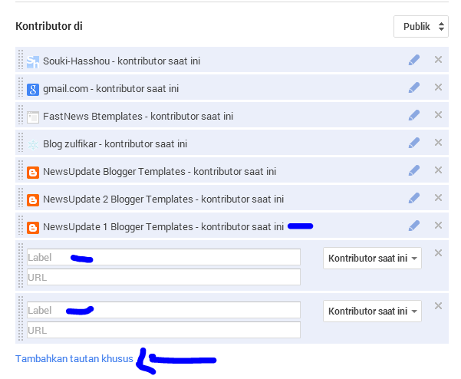

4. Click **add a special link** or **tambahkan tautan khusus**

**Edit Menu Navigation**

1. **Find this code**

**<nav id=’menu’>**

1. **and then change the menu content according to your liking**
2. **Like this**

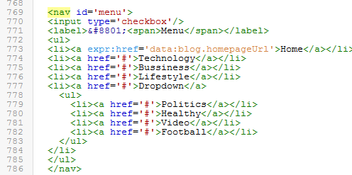

**PREVIEW**

